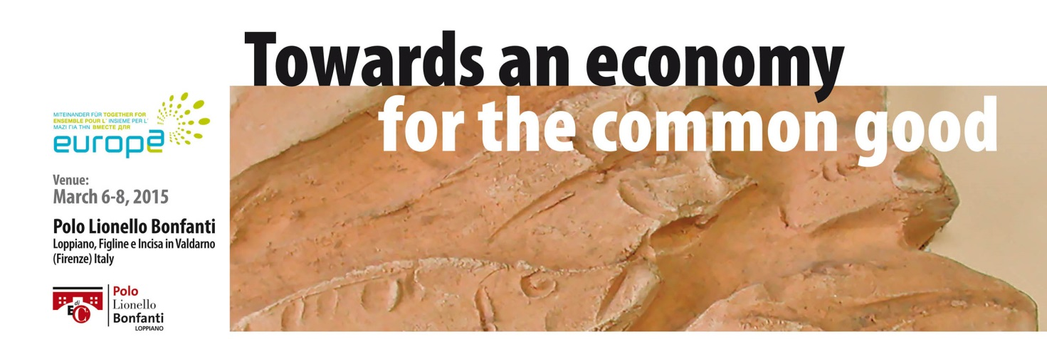

**TO KNOW FOR THE CONFERENCE:**

FIND THE CARD FOR ENTRIES TO THIS LINK:

<http://www.pololionellobonfanti.it/towards-an-economy-for-the-common-good/>

DEADLINE : February 15, 2015

TRANSLATION : We would arrange the translation according to need ; are planned for the moment , apart from English , Italian , French , and German.

AIRPORT : The nearest airport to the place of the conference is Florence airport.

TRANSFER : those who need transfer (from Florence airport / Florence Station / Incisa station ) to the place of the conference can make a request to the secretary who will organize the transfer (surcharge) collecting the various needs .

The Secretary will organize the transfer from the conference venue to hotels.

ACCOMMODATION: In the registration form you will find the various accommodation options :

The booking and other services will be confirmed by the Secretary by mail. Rooms will be assigned based on availability on the day of the request.

Hotel EUROPA 2 Stars - IncisaValdarno (FI - Single room 50 €

HotelTOSCANA 3 Stars - Figline V.no (FI) – Single room € 60 - € 45 Double room - [www.albergo-toscana.com](http://www.albergo-toscana.com)

Hotel MODERNO 4 Stars - Pontassieve (FI) - Single room € 65 - € 45 Double room - info [www.hotelmodernofirenze.it](http://www.hotelmodernofirenze.it)

Relais VILLA AL VENTO 5 Stars - IncisaValdarno (FI) - Single room € 100 – Double room 60 € - info [www.relaisvillaalvento.com](http://www.relaisvillaalvento.com)

- participation fee EURO 50,00

- MEALS EURO 15.00 (Friday dinner, Saturday lunch and dinner).

Persons requiring other meals pls notify the secretary in advance.

Free WIFI is available during the conference.

BABY SITTING: on request

For any further request pls contact the secretary of Polo Lionello Bonfanti

**Per info:** +39.055.8330400 – Fax +39.055.8330444 – Mail [info@edicspa.com](mailto:info@edicspa.com)